Assignment No -: 01

Que -: Create Table With The following Given Structures and Insert Sample Data

1] Salespeople-:

kd2_83598>create table salespeople
-> (
-> Snum int(4),
-> Sname varchar(10),
-> city varchar(10),
-> comm float(3,2)
-> );

insert into salespeople
-> values(1001,'peel','london',.12),
-> (1002,'Serres','San jose',.13),
-> (1004,'Motika','london',.11),
-> (1007,'Rifkin','Barcelona',.15),
-> (1003,'Axelrod','New York',.10);

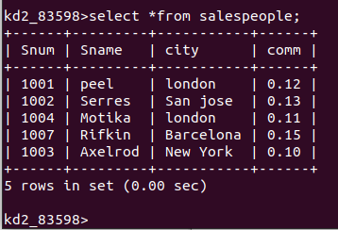

2] Customers -:

kd2_83598>create table Customers
-> (
-> Cnum int(4),
-> Cname varchar(10),
-> City varchar(10),
-> Rating int(4),
-> Snum int(4)
-> );

kd2_83598>insert into Customers
-> values(2001,'Hoffman','London',100,1001),
-> (2002,'Giovanni','Rome',200,1003),
-> (2003,'Liu','San Jose',200,1002),
-> (2004,'Grass','Berlin',300,1002),
-> (2006,'clemens','London',100,1001),
-> (2008,'Cisneros','San Jose',300,1007),
-> (2007,'pereira','Rome',100,1004);

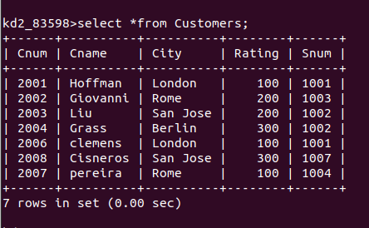

3] orders -:

kd2_83598>create table orders
-> (
-> onum int(4),
-> amt float(7,2),
-> odate date,
-> Cnum int(4),
-> snum int(4)
-> );

insert into orders
-> values(3001,18.69,'1990-10-03',2008,1007),
-> (3003,767.19,'1990-10-03',2001,1001),
-> (3002,1900.10,'1990-10-03',2007,1004),
-> (3005,5160.45,'1990-10-03',2003,1002),
-> (3006,1098.16,'1990-10-03',2008,1007),
-> (3009,1713.23,'1990-10-04',2002,1003),
-> (3007,75.75,'1990-10-04',2004,1002),
-> (3008,4723.00,'1990-10-05',2006,1001),
-> (3010,1309.95,'1990-10-06',2004,1002),
-> (3011,9891.88,'1990-10-06',2006,1001);

